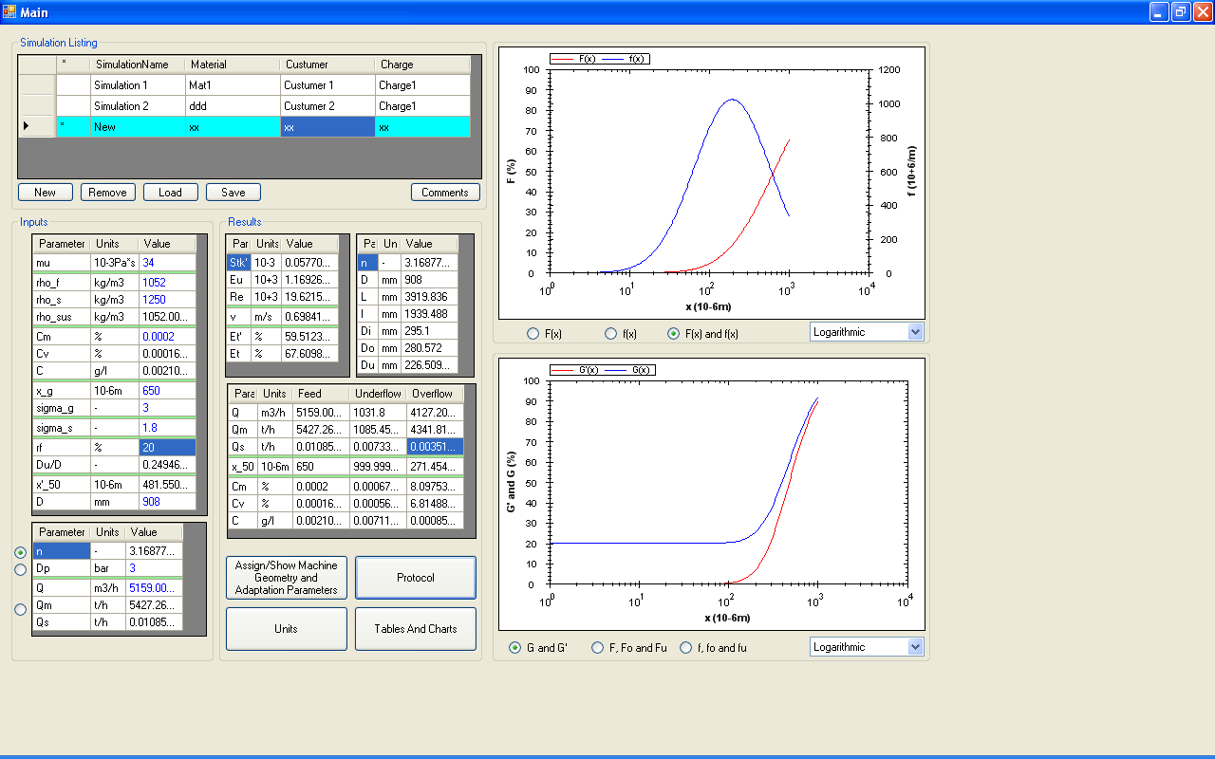
We have a problem with the display of the Cm and Cv values in the overflow. These values should be smaller than those of the feed and the underflow. Please enable the correct display.
Also please correct the curves so that they reach the 100% in the y-axis.

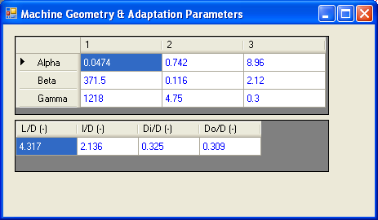
Data for the calculations in the main window.
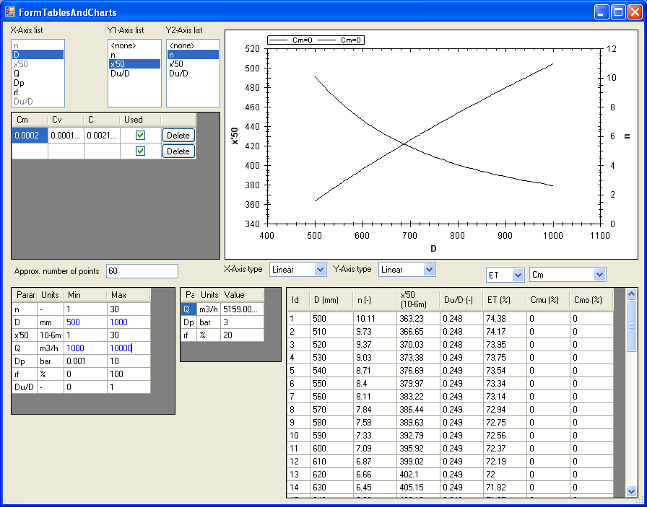
Please enable the correct display of these values. You have to allow more decimal points in this case because we have very small numbers.

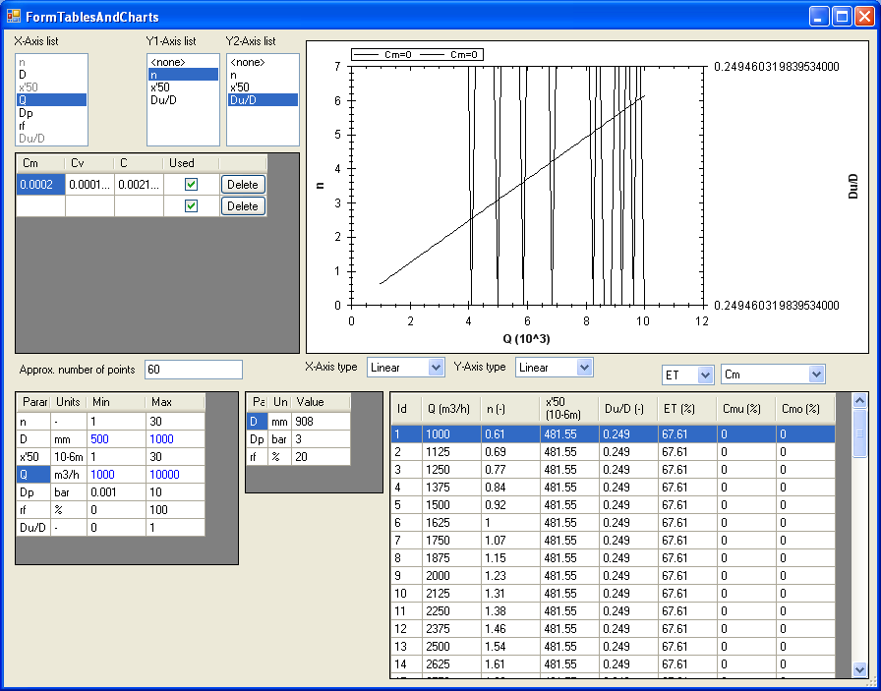
Please correct this problem with the graphs.

Please correct also the protocol (see attached protocol with the sent Email).
The determination of the parameters xg and sg when the particle size distribution F(x) is given as table values
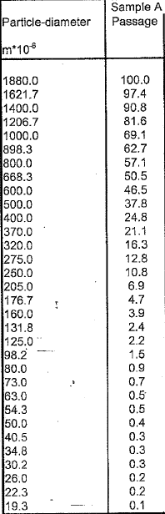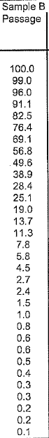

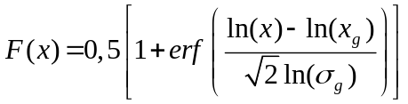

The first column of the above table is the x-parameter (particle size) in micrometer. The second column is the F(x) in % for sample A. The third column is F(x) in 5 for sample B.

Task
Please use the above equation and the above table and determine via regression analysis the parameters xg and sg for sample A and for sample B and draw the curves (calculated values) and compare with the measured values.(x-axis logarithmic and y-axis (F(x)) linear.

